User Manual: Photo Service Application

Authors: Kenneth Mallabo & Zinah Al-Baghdadi

Last Updated: 04/12/22

# Introduction

This document is made for the purpose for the user or developer on how to run and navigate the Photo Service Application. Please note that it is assumed that the necessary components such as the database, Netbeans IDE, its dependencies etc., have already been installed and placed in appropriate file locations in order for the application to run

# How to use the application

## Start-up

To start the application, the user has to use the Netbeans IDE. One of the ways to start the PhotoServiceApp1.java code/application is to right click on this application on the Projects side bar and then choose “Run File”.

## Home Page

Once the application is finished loading, the user is directed to the main home page. It merely serves as a page to welcome the user and shows information about the business.

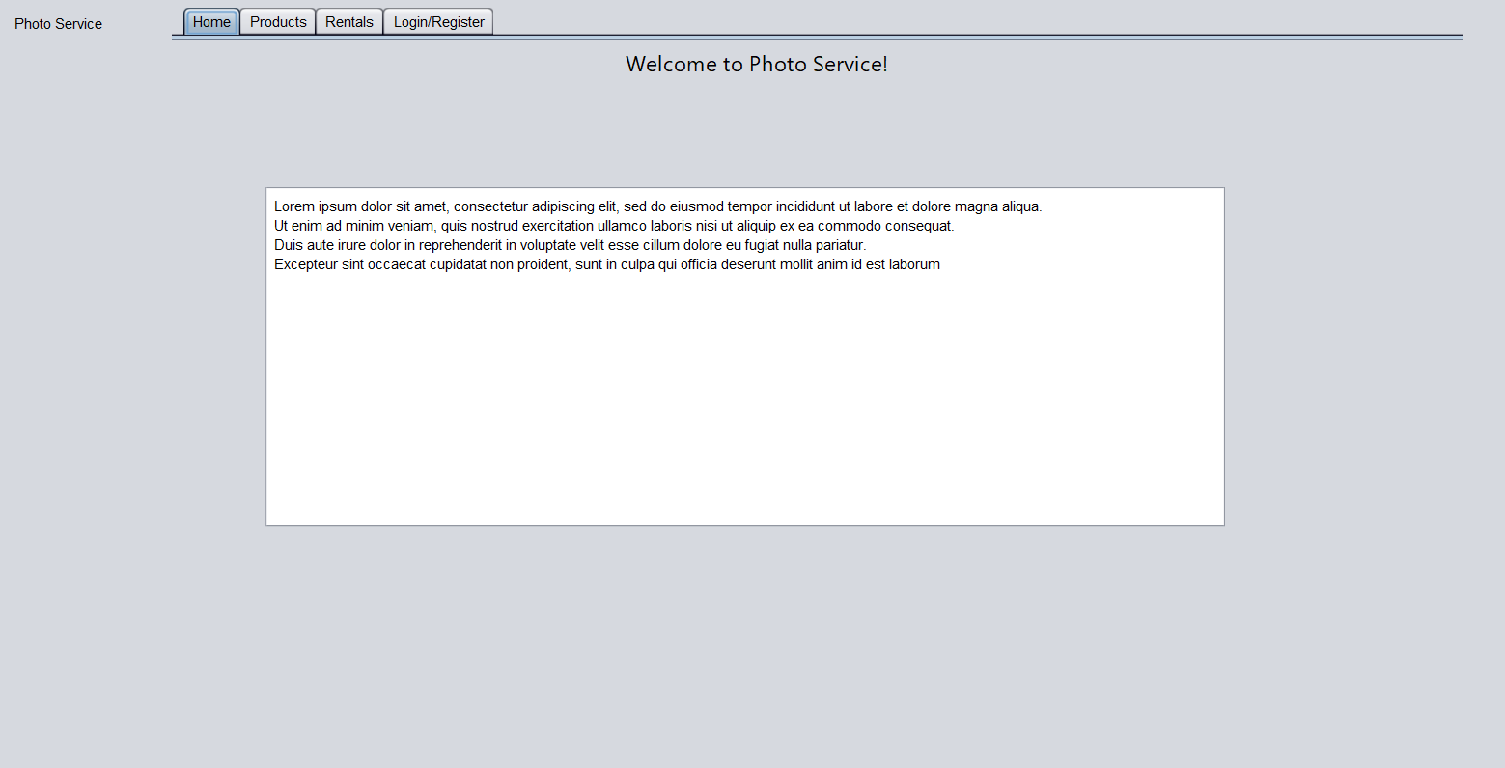

Figure : Home Page

## Products Page

## Rentals Page

## Login/Register

This tab has multiple subtabs underneath it. Most of the subtabs are hidden by default and would only appear upon the user using its login credentials.

### Login

This page/panel is a way for the user to enter its credentials by entering a username and its password. A popup message would appear to inform the user if the action has been successful or not. If successful, more tabs would appear and some tabs would be removed like the login page. The tabs that would appear would depend if the user was a client or an admin.

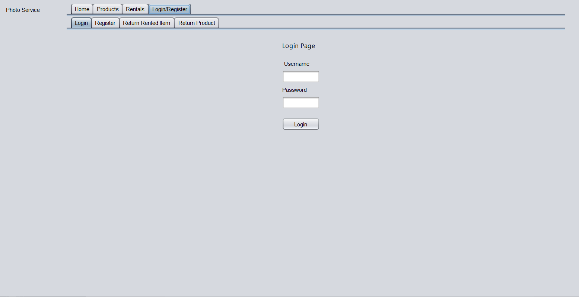

Figure : Login subtab

### Register

The register page allows the user to create a client account by entering a username, its password and then the password again to make sure that the user has entered the intended password. A popup would appear to tell the user if the action was successful or not, one of messages could be that the username is already taken.

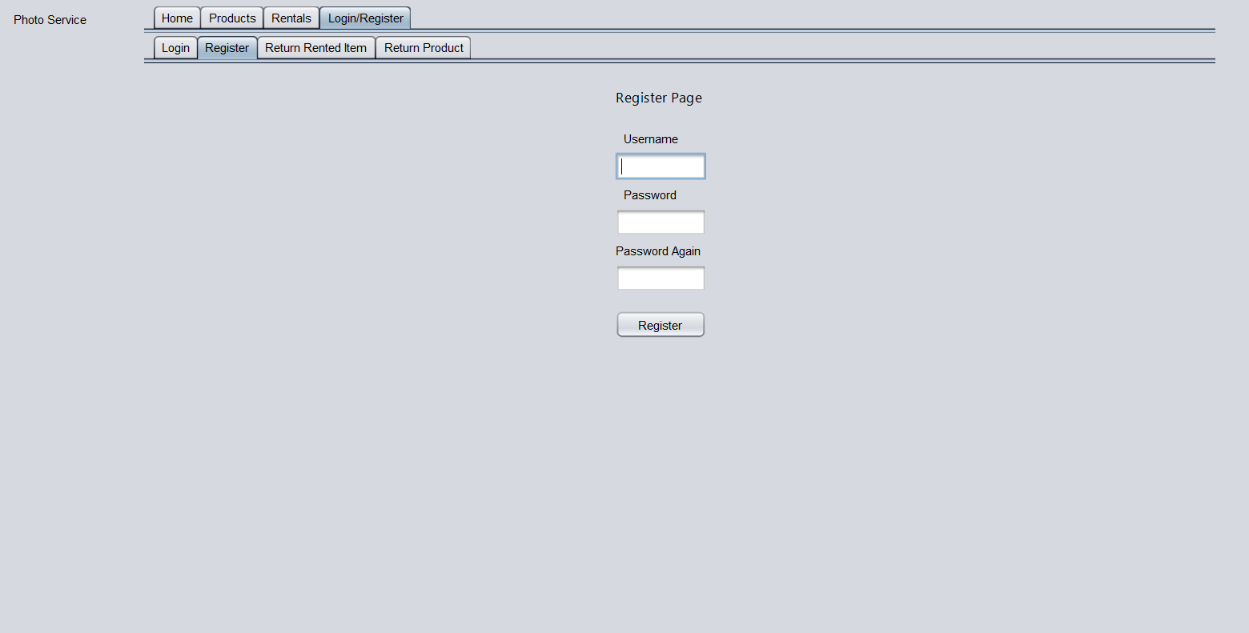

Figure : Register subtab

### Settings

The settings page is one of the subtabs that would only appear if the admin has logged in. The purpose of this page is for the admin to remove a client from the database by entering its username. A popup would appear telling if they wish to proceed and if the user chose yes then another popup would appear to notify the action was successful or not.

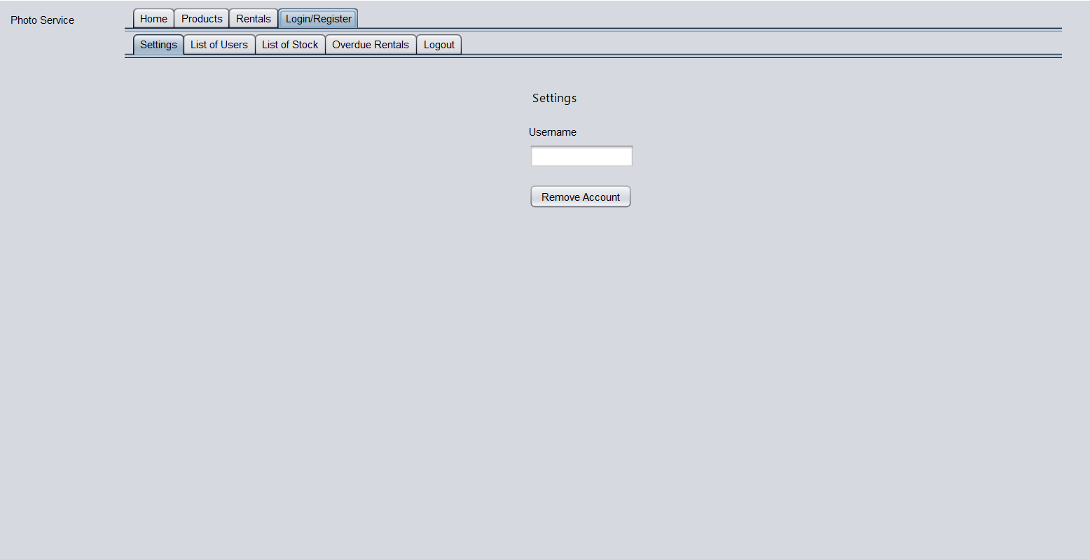

Figure : Settings Page

### Return Rented Item, Return Product

These two subtabs are functionally similar to each other with the Return Rented Item allows the user to return their rented item by entering username and its Item ID whilst the Return Product allows the user to return their product by entering their username and its Item ID. Both would notify the user if the action was successful or not.

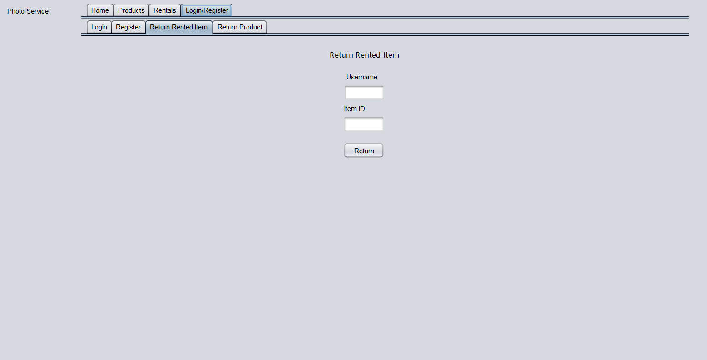

Figure : Return Rented Item subtab

### List of Users, List of Stock, Overdue Rentals

These three sub tabs would only appear if the admin has been logged in. The subtabs would automatically retrieve data from the database and show the user either a list of users, stock and overdue rentals depending the selected subtab. Please note that the information shown are not updated when there are changes done in the database. To see them requires a restart of the application.

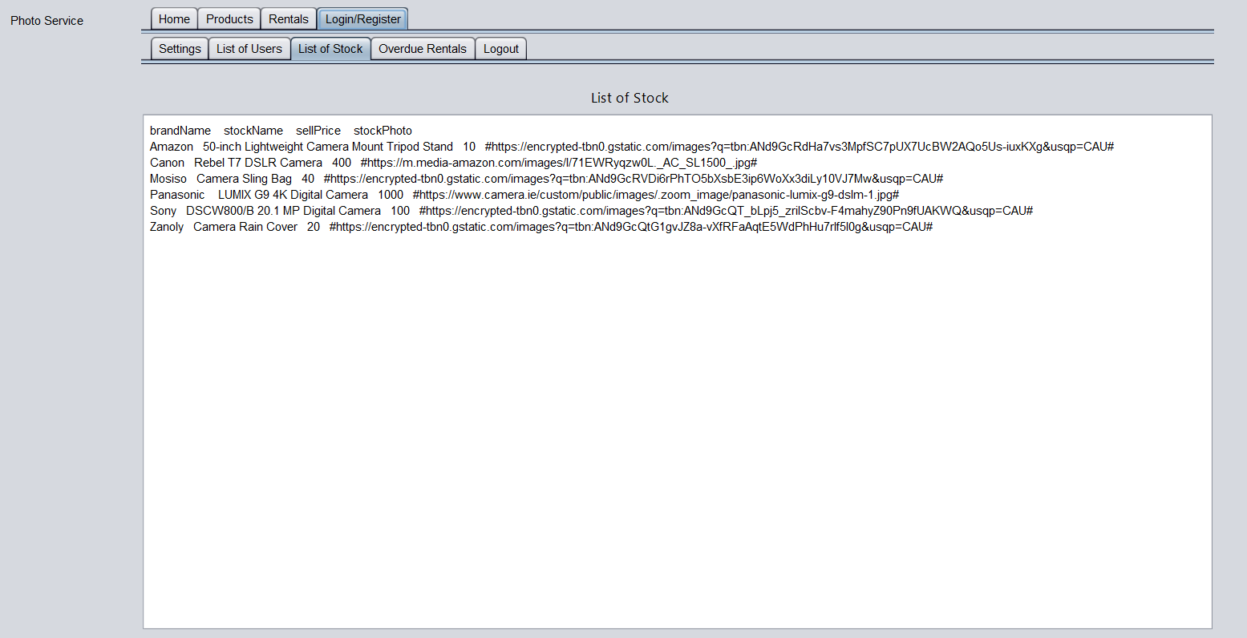

Figure 6: List of Stock subtab

### Logout

This subtab appears if the user has already logged in. If the user presses the logout button, then a popup message notifies that they logged out and the sub tabs shown will be the same before they logged in.

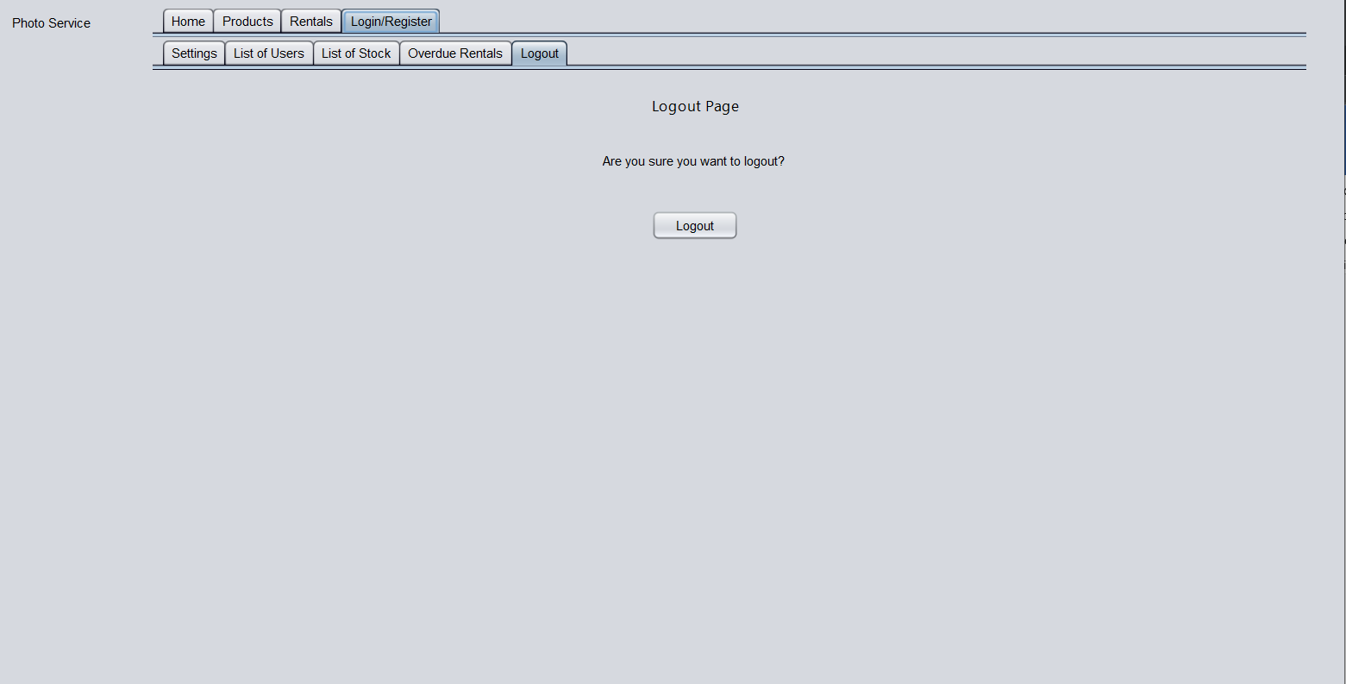

Figure : Logout subtab